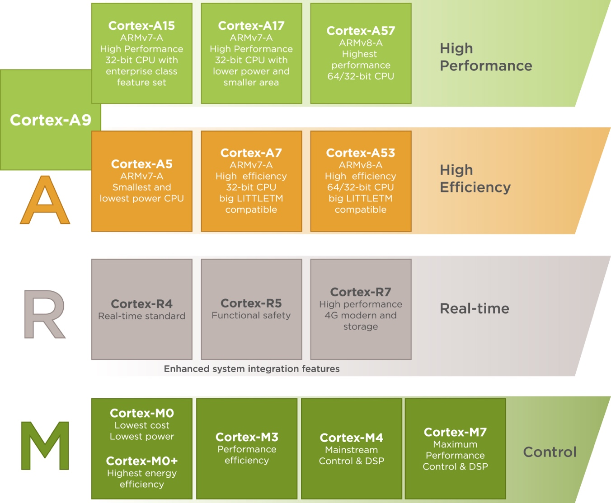

**ARM M-series microprocessor (Cyclic Executive):**

The point of interest of Cortex-M processors is the MCU market. The first processor of this set was released more than 13 years ago. Since then, the popularity of M-processors has clearly risen: now, Cortex-M is known as an industry standard. The ARM processors of this type find their implementation in FPGA, integrated memories, clocks, etc. Different members of the set have different improved features: some of them demonstrate higher performance, others are more energy efficient. Of course, each of the designed controllers is tailored to a particular segment of the market.

The areas of application of M-category ARM processors are:

* Motion Sense Devices.
* Smartwatches.
* Smart Lighting.
* Automotive, Retail & Healthcare Industries.
* Energy Grids.

**ARM R-series microprocessor (RTOS):**

Cortex-R processors primarily target real-time solutions. They find application in controllers, networking equipment, media players, and other similar devices. Furthermore, this type of ARM processor provides great support for the automotive industry.

Cortex-R processors have a lot in common with high-end microcontrollers, but at the same time have the ability to fulfill more scalable tasks.

The areas of application of Cortex-M ARM processors include:

* Industrial, Automotive, & Enterprise purposes.
* Cameras.
* Mobile Handsets.
* Data Storage.

**ARM A-series microprocessor (Linux + RT extensions):**

The Cortex-A category of processors is dedicated to Linux and Android devices. Any devices – starting from smartwatches and tablets and continuing with networking equipment – can be supported by Cortex-A processors.

Some technical information:

* The ARMv7-A architecture forms the basis of the A5, A7, A8, A9, A12, A15, and A17 processors.
* The set of common features for A-processors includes a media processing engine (NEON), a tool for security purposes (Trustzone), and various supported instruction sets (ARM, Thumb, DSP etc).
* The main features of Cortex-A processors are top performance and brilliant power efficiency closely bundled to provide users with the best service possible.

Nothing describes the ARM Cortex-A processors better than their applications and potential usage:

* Smart Devices and Wearables.
* Automotive Systems.
* Servers & Networks.
* Satellite Receivers.
* Home Gateways.

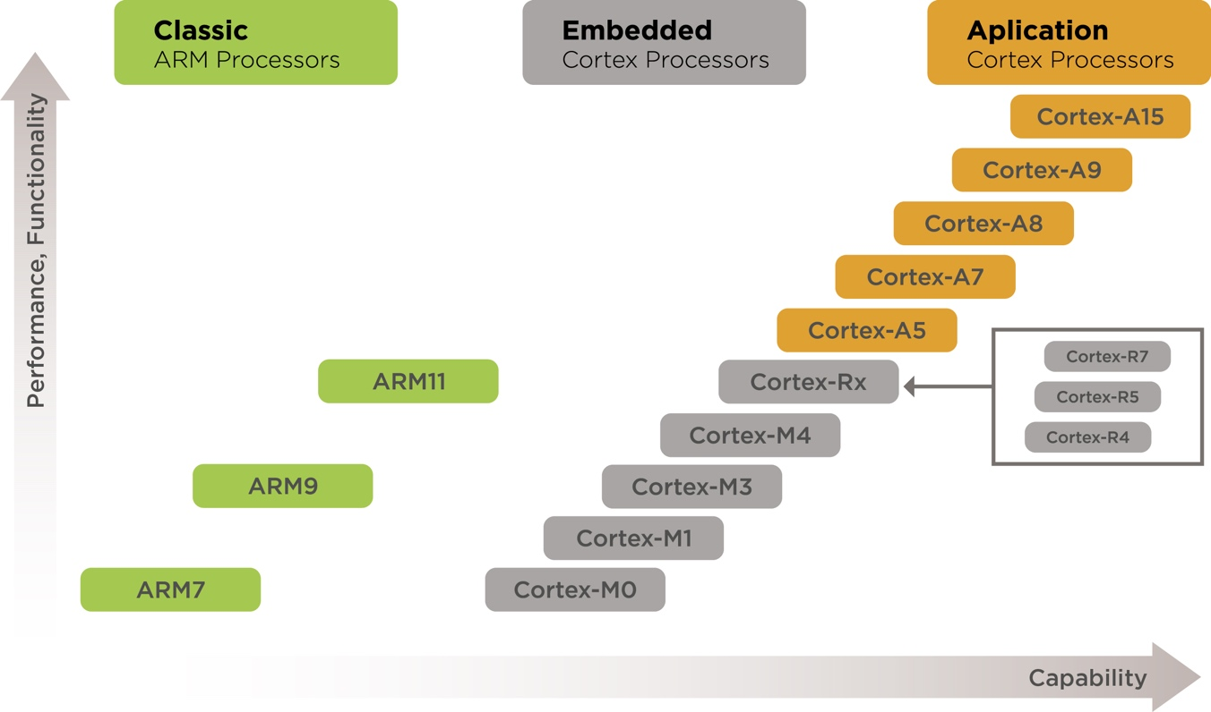

Source: https://sirinsoftware.com/blog/the-arm-processor-a-r-and-m-categories-and-their-specifics/